|  |  |  |  |  |
| --- | --- | --- | --- | --- |
| id_karyawan | nama_karyawan | kode_pekerjaan | nama_pekerjaan | alamat |
| K001 | Rusdi | G01 | Manager | Jln. Anggrek I |
| K002 | Slamet Kopling | G07 | Mechanic | Jln. Mawar V |
| K003 | Sigit Rendang | Jln. Melati II |
| K004 | Eko Lengkuas | G05 | Designer | Jln. Melati III |
| K005 | Gogon Tunjang | G06 | Security | Jln. Jalan IV |

1NF

|  |  |  |  |  |
| --- | --- | --- | --- | --- |
| id_karyawan | nama_karyawan | kode_pekerjaan | nama_pekerjaan | alamat |
| K001 | Rusdi | G01 | Manager | Jln. Anggrek I |
| K002 | Slamet Kopling | G07 | Mechanic | Jln. Mawar V |
| K003 | Sigit Rendang | G07 | Mechanic | Jln. Melati II |
| K004 | Eko Lengkuas | G05 | Designer | Jln. Melati III |
| K005 | Gogon Tunjang | G06 | Security | Jln. Jalan IV |

2NF

|  |  |
| --- | --- |
| id_karyawan | kode_pekerjaan |
| K001 | G01 |
| K002 | G07 |
| K003 | G07 |
| K004 | G05 |
| K005 | G06 |

|  |  |  |
| --- | --- | --- |
| id_karyawan | nama_karyawan | alamat |
| K001 | Rusdi | Jln. Anggrek I |
| K002 | Slamet Kopling | Jln. Mawar V |
| K003 | Sigit Rendang | Jln. Melati II |
| K004 | Eko Lengkuas | Jln. Melati III |
| K005 | Gogon Tunjang | Jln. Jalan IV |

|  |  |
| --- | --- |
| kode_pekerjaan | nama_pekerjaan |
| G01 | Manager |
| G07 | Mechanic |
| G07 | Mechanic |
| G05 | Designer |
| G06 | Security |

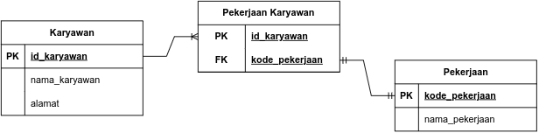Tabel Relasional

ERD

